DEPARTMENT OF COMMERCE & MANAGEMENT
SL.NO | DETAILS OF THE EVENT
1. | Title of The Event | BAMUL Industrial Visit
2 | Day and Date | 29/04/2026
3 | Venue | BAMUL, Dairy Circle
4 | Organizing Secretary/ Co-Coordinators | Commerce & Management
5 | Chief Guest | Nil
6 | Participants | IV & VI BCOM
6 | No of Student and staff present | 100 Students

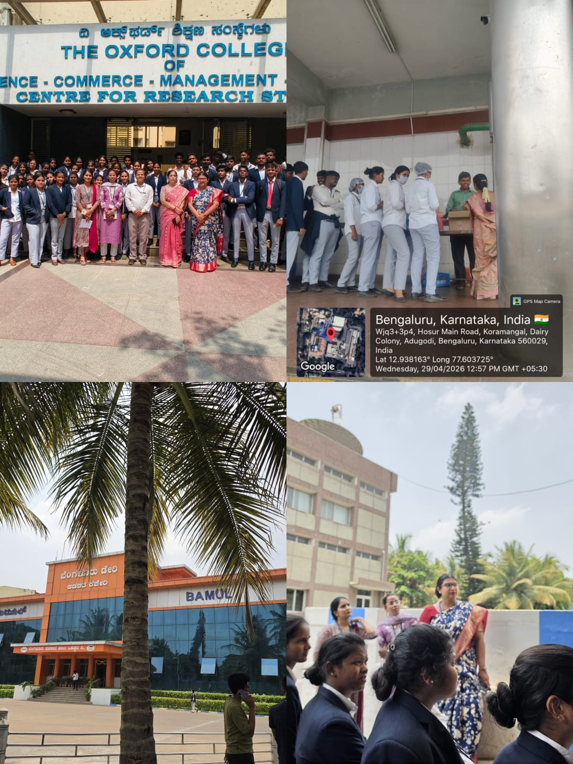

Department of Commerce & Management planned and organised an industrial visit was arranged to Bangalore Dairy (BAMUL). Students of IV & VI BCOM participated in the event and total 100 students were involved in learning the process of production of milk products, sweets, ghee , butter and butter milk, supply and logistics.

Coordinator HOD Vice-Principal Principal

